

International School

**Capstone Project 1**

*CMU-SE 450*

**DATABASE DESIGN**

*Version: 1.0*

*Date: 25/10/2021*

**School Connect Application**

**Submitted by:**

Nguyen Thanh Phu

Nguyen Trung Hieu

Dang Nguyen Bao Hoai

**Approved by**

Nguyen Minh Nhat

**Proposal Review Panel Representative:**

Name Signature Date

**Capstone Project 1- Mentor:**

Name Signature Date

# Project Information

|  |  |  |  |  |
| --- | --- | --- | --- | --- |
| **Project acronym** | SConA | | | |
| **Project Title** | School Connect Application | | | |
| **Start Date** | 22-Aug-2021 | **End Date** | | 18-Dec-2021 |
| **Lead Institution** | International School, Duy Tan University | | | |
| **Project Mentor & contact details** | Name: Nguyen Minh Nhat  Email: nhatnm2010@gmail.com  Tel: +84 905 125 143 | | | |
| **Scrum Master & contact details** | Name: Nguyen Thanh Phu  Email: [thangphu104@gmai.com](mailto:thangphu104@gmai.com)  Tel: +84 772 492 301 | | | |
| **Team members** | **Name** | **Email** | **Tel** | |
| Nguyen Trung Hieu | hnguyentrung20@gmail.com | +84 975 299 149 | |
| Dang Nguyen Bao Hoai | dangbhoai@gmail.com | +84 773 305 395 | |

|  |  |  |  |
| --- | --- | --- | --- |
| **DOCUMENT INFORMATION** | | | |
| **Document Title** | Database Design | | |
| **Author(s)** | Team C1SE.44 | | |
| **Role** | C1SE.44- Database Design -SConAdocx-v1.0 | | |
| **Date** | 03-Nov-2021 | **Filename** | C1SE.44-DatabaseDesign-SConAdocx-v1.0 |
| **URL** | **https://github.com/PhuNguyenThang/Capstone1** | | |
| **Access** | Project and CMU Program | | |

**DOCUMENT APPROVALS**

The following signatures are required for approval of this document.

|  |  |  |
| --- | --- | --- |
| Nguyen Minh Nhat  *Mentor* | Signature | Date |
| Nguyen Thanh Phu  *Scrum Master* | Signature | Date |
| Nguyen Trung Hieu  *Product owner* | Signature | Date |
| Dang Nguyen Bao Hoai  *Product owner* | Signature | Date |

REVISION HISTORY

|  |  |  |  |  |
| --- | --- | --- | --- | --- |
| **Version** | **Date** | **Comments** | **Author** | **Approval** |
| 1.0 | 25-Oct-2021 | Create database design document | Nguyen Thanh Phu |  |

Table of Contents

Project Information 2

1. Introduction 6

**1.1.Purpose** 6

**1.2.Goal** 6

**1.3.Scope** 6

**1.4.Data storage platforms** 6

2 Database Diagram 7

**2.1Table Overview** 7

**2.2Table Relationship Diagram** 7

**2.3Table Diagram** 8

3 Table Details 10

• *Table 01: user* 10

• *Table 02: users_roles* 10

• *Table 03: roles* 10

• *Table 04: forums* 11

• *Table 05: member_forums* 11

• *Table 06: post* 12

• *Table 07: image_post* 12

• *Table 08: post_forum* 12

• *Table 09: comment* 13

• *Table 10: member_event* 13

• *Table 11: notify* 13

• *Table 12: report_post* 14

• *Table 13: report_comments* 14

• *Table 14: member_notify* 15

1. **Introduction**
   1. **Purpose**

Place information system’s database design document describes structure of database and file structure of system. Database Design document will introduce all attribute the System that will help developer and tester base on this design to implement and test.

* 1. **Goal**

To create database tables most accurate.

* 1. **Scope**

This Database Design Document provides the basic for “School Connect Application” Database design.

It describes both logical and physical definition, non-functional issues, and the database interfaces; storage aspects are defined in the physical database design sections.

The tables performance considerations requirements. The following topics are covered in this document:

* Assumptions and decisions on database design.
* Entity-mapping.
* Table column definitions.
* Primary, unique and foreign key definitions.
* Column and row level validation rules (check constraints).
* Rule for populating specific columns (sequences, derivations, demoralized (column)).
* Interfaces and dependencies with other components.
* Data access description.

The database design for “Demark – Decentralized Market” is composed of definitions for database objects derived by mapping entities to tables attributes to columns, unique identifiers to unique keys and relationship to foreign keys.

During design, these initial definitions are enhanced to support the functionality described in the functional specification/ user stories and defined in the primary and supporting modules of the application high level design.

* 1. **Data storage platforms**

- Data of application is stored in MySQL database

- In MySQL, data structure is stored as tables that the database objects that behave as containers for the data, in which the data will be logically organized in rows and columns format.

1. **Database Diagram**
   1. **Table Overview**

|  |  |
| --- | --- |
| **Table name** | **Short Description** |
| users | This table shows user information including all related fields. |
| users_roles | This table shows role of user for website |
| roles | This table shows all role have in the website |
| forum | This table shows all forum information including censor of forum. |
| member_forums | This table shows all members have in the forum and status of member in forum. |
| post | This table shows all posts information including user has post |
| post_forum | This table shows post in the forum |
| image_post | This table shows all link image of the posts. |
| comment | This table shows all comment of user for the post. |
| member_event | This table show all event member has join |
| member_notify | This table show all notify for user |
| notify | This table show all information notify |
| report_comments | This table show all report of comment |
| report_post | This table show all report of post |

* 1. **Table Relationship Diagram**

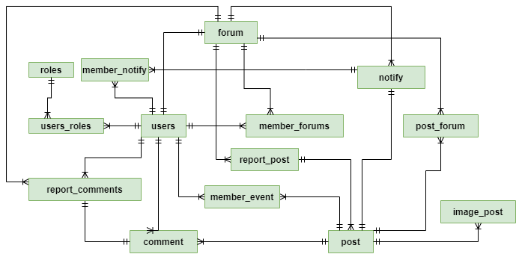



* 1. **Table Diagram**

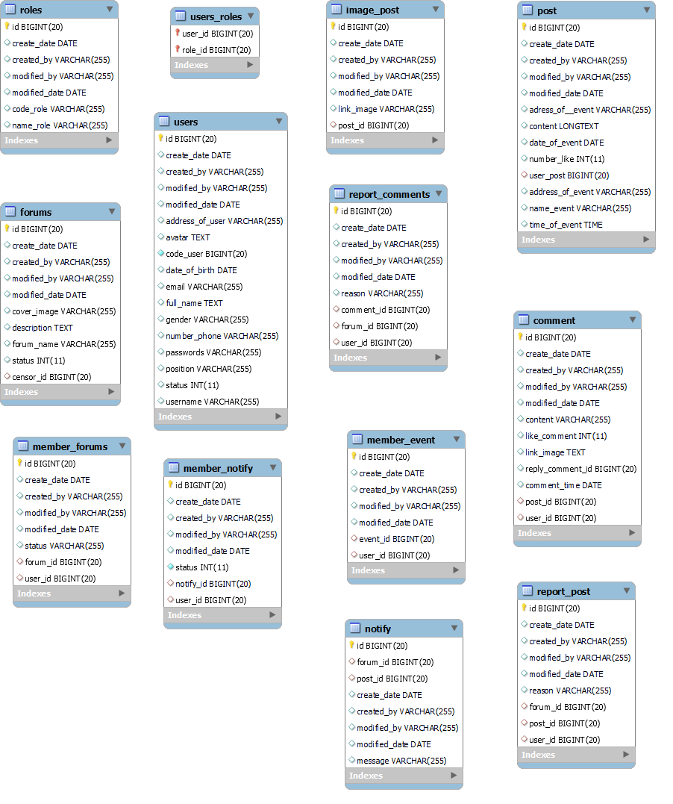

1. **Table Details**

* ***Table 01: user***

|  |  |  |  |  |
| --- | --- | --- | --- | --- |
| **ID** | **Field** | **Type** | **Constraint** | **Description** |
| **1** | id | BIGINT | Primary key | User id |
| **2** | create_date | DATE |  | Record creation date |
| **3** | create_by | VARCHAR (255) |  | Record creator |
| **4** | modified_by | VARCHAR (255) |  | Record editor |
| **5** | modified_date | DATE |  | Record edit date |
| **6** | code_user | BIGINT (20) | Unique | User code |
| **7** | username | VARCHAR (255) | Unique | Username for login |
| **8** | password | VARCHAR (255) |  | Password for login |
| **9** | email | VARCHAR (255) | Unique | Email of user |
| **10** | full_name | VARCHAR (255) |  | Full name of user |
| **11** | gender | VARCHAR (255) |  | Gender of user |
| **13** | date_of_birth | DATE |  | Date of birth of user |
| **14** | avatar | TEXT |  | Avatar of user |
| **15** | number_phone | VARCHAR (255) |  | Number phone of user |
| **16** | position | VARCHAR (255) |  | Position of user |
| **17** | status | INT (11) |  | Status of user in system |

* ***Table 02:*** ***users_roles***

|  |  |  |  |  |
| --- | --- | --- | --- | --- |
| **ID** | **Field** | **Type** | **Constraint** | **Description** |
| **1** | user_id | BIGINT (20) | Primary key, Foreign key (user) | Id of user |
| **2** | role_id | BIGINT (20) | Primary key, Foreign key (user) | Id of role |

* ***Table 03:*** ***roles***

|  |  |  |  |  |
| --- | --- | --- | --- | --- |
| **ID** | **Field** | **Type** | **Constraint** | **Description** |
| **1** | id | BIGINT (20) | Primary key | Role id |
| **2** | create_date | DATE |  | Record creation date |
| **3** | create_by | VARCHAR (255) |  | Record creator |
| **4** | modified_by | VARCHAR (255) |  | Record editor |
| **5** | modified_date | DATE |  | Record edit date |
| **6** | code_role | VARCHAR (255) |  | Code of role |
| **7** | name_role | VARCHAR (255) |  | Name of role |

* ***Table 04: forums***

|  |  |  |  |  |
| --- | --- | --- | --- | --- |
| **ID** | **Field** | **Type** | **Constraint** | **Description** |
| **1** | id | BIGINT (20) | Primary key | Forum id |
| **2** | create_date | DATE |  | Record creation date |
| **3** | create_by | VARCHAR (255) |  | Record creator |
| **4** | modified_by | VARCHAR (255) |  | Record editor |
| **5** | modified_date | DATE |  | Record edit date |
| **6** | forum_name | VARCHAR (255) |  | Name of forum |
| **7** | description | TEXT |  | Description of forum |
| **8** | cover_image | TEXT |  | Cover image of forum |
| **9** | status | INT (11) |  | Status of forum |
| **10** | censor_id | VARCHAR (255) | Foreign key (user) | User id of censor manage forum |

* ***Table 05: member_forums***

|  |  |  |  |  |
| --- | --- | --- | --- | --- |
| **ID** | **Field** | **Type** | **Constraint** | **Description** |
| **1** | id | INT (20) | Primary key | Role id |
| **2** | create_date | DATE |  | Record creation date |
| **3** | create_by | VARCHAR (255) |  | Record creator |
| **4** | modified_by | VARCHAR (255) |  | Record editor |
| **5** | modified_date | DATE |  | Record edit date |
| **7** | forum_id | BIGINT (20) | Foreign key (forums) | Id of forums |
| **8** | user_id | BIGINT (20) | Foreign key (user) | Id of user |
| **9** | status | VARCHAR (255) |  | Status of member |

* ***Table 06: post***

|  |  |  |  |  |
| --- | --- | --- | --- | --- |
| **ID** | **Field** | **Type** | **Constraint** | **Description** |
| **1** | id | BIGINT (20) | Primary key | Post id |
| **2** | create_date | DATE |  | Record creation date |
| **3** | create_by | VARCHAR (255) |  | Record creator |
| **4** | modified_by | VARCHAR (255) |  | Record editor |
| **5** | modified_date | DATE |  | Record edit date |
| **6** | content | LONG TEXT |  | Content in post |
| **7** | address_of_event | VARCHAR (255) |  | Address of event in post |
| **8** | date_of_event | DATE |  | Date of event in post |
| **9** | number_like | INT (11) |  | Number of like in post |
| **10** | user_id | BIGINT (20) | Foreign key (user) | Id of user create post |

* ***Table 07: image_post***

|  |  |  |  |  |
| --- | --- | --- | --- | --- |
| **ID** | **Field** | **Type** | **Constraint** | **Description** |
| **1** | id | BIGINT (20) | Primary key | Image id |
| **2** | create_date | DATE |  | Record creation date |
| **3** | create_by | VARCHAR (255) |  | Record creator |
| **4** | modified_by | VARCHAR (255) |  | Record editor |
| **5** | modified_date | DATE |  | Record edit date |
| **6** | link_image | VARCHAR (255) |  | Link image of post |
| **7** | post_id | BIGINT (20) | Foreign key (post) | Id of post |

* ***Table 08: post_forum***

|  |  |  |  |  |
| --- | --- | --- | --- | --- |
| **ID** | **Field** | **Type** | **Constraint** | **Description** |
| **1** | id | BIGINT (20) | Primary key | Id post in forum |
| **2** | create_date | DATE |  | Record creation date |
| **3** | create_by | VARCHAR (255) |  | Record creator |
| **4** | modified_by | VARCHAR (255) |  | Record editor |
| **5** | modified_date | DATE |  | Record edit date |
| **6** | forum_id | BIGINT (20) | Foreign key (forums) | Id of forum |
| **7** | post_id | BIGINT (20) | Foreign key (post) | Id of post |
| **8** | status | VARCHAR (255) |  | Status post in forum |

* ***Table 09: comment***

|  |  |  |  |  |
| --- | --- | --- | --- | --- |
| **ID** | **Field** | **Type** | **Constraint** | **Description** |
| **1** | id | BIGINT (20) | Primary key | Id comment |
| **2** | create_date | DATE |  | Record creation date |
| **3** | create_by | VARCHAR (255) |  | Record creator |
| **4** | modified_by | VARCHAR (255) |  | Record editor |
| **5** | modified_date | DATE |  | Record edit date |
| **6** | content | VARCHAR (255) |  | Content of comment |
| **7** | like_comment | INT (11) |  | Like of comment |
| **8** | link_image | TEXT |  | Link image of comment |
| **9** | reply_comment_id | BIGINT (20) |  | Reply of comment |
| **10** | comment_time | DATE |  | Time comment |
| **11** | post_id | BIGINT (20) | Foreign key (post) | Id of post |
| **12** | user_id | BIGINT (20) | Foreign key (user) | Id of user comment |

* ***Table 10: member_event***

|  |  |  |  |  |
| --- | --- | --- | --- | --- |
| **ID** | **Field** | **Type** | **Constraint** | **Description** |
| **1** | id | BIGINT (20) | Primary key | Id comment |
| **2** | create_date | DATE |  | Record creation date |
| **3** | create_by | VARCHAR (255) |  | Record creator |
| **4** | modified_by | VARCHAR (255) |  | Record editor |
| **5** | modified_date | DATE |  | Record edit date |
| **6** | event_id | BIGINT (20) | Foreign key (post) | Id of post |
| **7** | user_id | BIGINT (20) | Foreign key (user) | Id of user comment |

* ***Table 11: notify***

|  |  |  |  |  |
| --- | --- | --- | --- | --- |
| **ID** | **Field** | **Type** | **Constraint** | **Description** |
| **1** | id | BIGINT (20) | Primary key | Id comment |
| **2** | create_date | DATE |  | Record creation date |
| **3** | create_by | VARCHAR (255) |  | Record creator |
| **4** | modified_by | VARCHAR (255) |  | Record editor |
| **5** | modified_date | DATE |  | Record edit date |
| **6** | forum_id | BIGINT (20) | Foreign key (forum) | Id of forum |
| **7** | message | VARCHAR (255) |  | Message of notify |
| **8** | post_id | BIGINT (20) | Foreign key (post) | Id of post |

* ***Table 12: report_post***

|  |  |  |  |  |
| --- | --- | --- | --- | --- |
| **ID** | **Field** | **Type** | **Constraint** | **Description** |
| **1** | id | BIGINT (20) | Primary key | Id comment |
| **2** | create_date | DATE |  | Record creation date |
| **3** | create_by | VARCHAR (255) |  | Record creator |
| **4** | modified_by | VARCHAR (255) |  | Record editor |
| **5** | modified_date | DATE |  | Record edit date |
| **6** | post_id | BIGINT (20) | Foreign key (post) | Id of post reported |
| **7** | user_id | BIGINT (20) | Foreign key (user) | Id of user report |
| **8** | forum_id | BIGINT (20) | Foreign key (forum) | Id of forum have post reported |
| **9** | reason | VARCHAR (255) |  | Reason of report |

* ***Table 13: report_comments***

|  |  |  |  |  |
| --- | --- | --- | --- | --- |
| **ID** | **Field** | **Type** | **Constraint** | **Description** |
| **1** | id | BIGINT (20) | Primary key | Id comment |
| **2** | create_date | DATE |  | Record creation date |
| **3** | create_by | VARCHAR (255) |  | Record creator |
| **4** | modified_by | VARCHAR (255) |  | Record editor |
| **5** | modified_date | DATE |  | Record edit date |
| **6** | comment_id | BIGINT (20) | Foreign key (comment) | Id of comment reported |
| **7** | user_id | BIGINT (20) | Foreign key (user) | Id of user report |
| **8** | forum_id | BIGINT (20) | Foreign key (forum) | Id of forum have comment reported |
| **9** | reason | VARCHAR (255) |  | Reason of report |

* ***Table 14: member_notify***

|  |  |  |  |  |
| --- | --- | --- | --- | --- |
| **ID** | **Field** | **Type** | **Constraint** | **Description** |
| **1** | id | BIGINT (20) | Primary key | Id comment |
| **2** | create_date | DATE |  | Record creation date |
| **3** | create_by | VARCHAR (255) |  | Record creator |
| **4** | modified_by | VARCHAR (255) |  | Record editor |
| **5** | modified_date | DATE |  | Record edit date |
| **6** | notify_id | BIGINT (20) | Foreign key (notify) | Id of notify |
| **7** | user_id | BIGINT (20) | Foreign key (user) | Id of user receiving the notice |
| **8** | status | INT (11) |  | Status of notify user has read or not |